Code Signing Certificate

What is Code Signing?
- Code signing is simply a guarantee that the code of a program or software download has not been corrupted and tampered with after it was signed by the publisher.
- Code signing is the process of digitally signing executable and scripts to confirm the software author and guarantee that the code has not been altered or corrupted since it was signed. The process employs the use of a cryptographic hash to validate authenticity and integrity
- Digital signatures use public key cryptography technology to secure and authenticate code.

Where can I get a Code Signing or Driver Signing Certificate?
To get a new code signing certificate:
1. Determine which certificate you need.
1 2. Go to the page of one the following certificate authorities and follow their directions for purchase:
  - Certum EV code signing certificate
  - DigiCert EV code signing certificate
  - Entrust EV code signing certificate
  - GlobalSign EV code signing certificate
  - IdenTrust EV code signing certificate
  - Sectigo (formerly Comodo) EV code signing certificate
  - SSL.com EV code signing certificate

How murata Code Signing works till 2021?

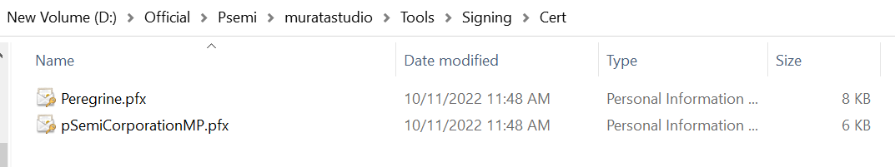
Murata studio project was using the certificates purchased from Go Daddy till 2021.

The certificate was valid only till 7/18/2021 as shown below.

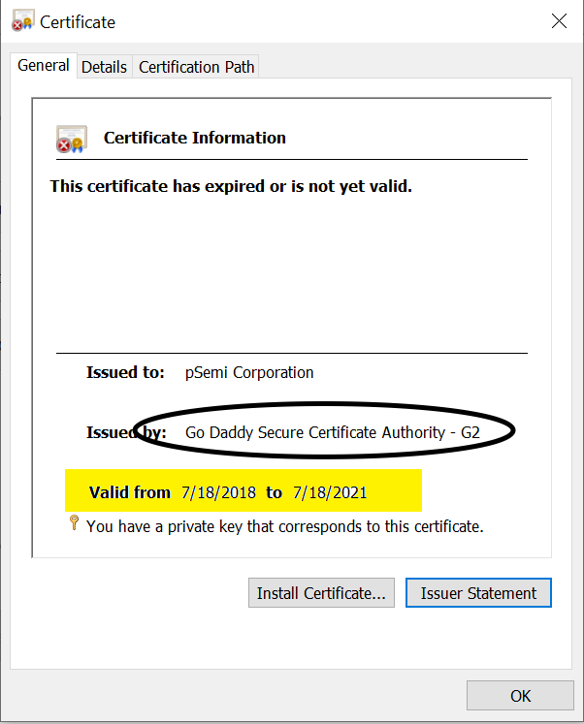

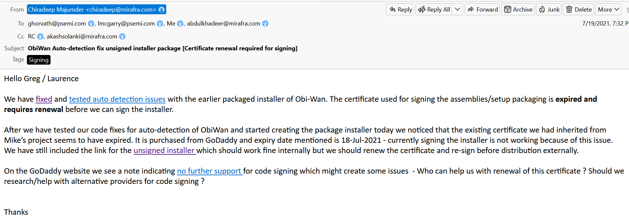
Once the certificate got expired, we have informed Psemi for purchasing new certificates as it has to be done via Psemi Organization.

As per Michael Polito (Previous free lance developer of murata studio project from whom we took the hand over of the project) :

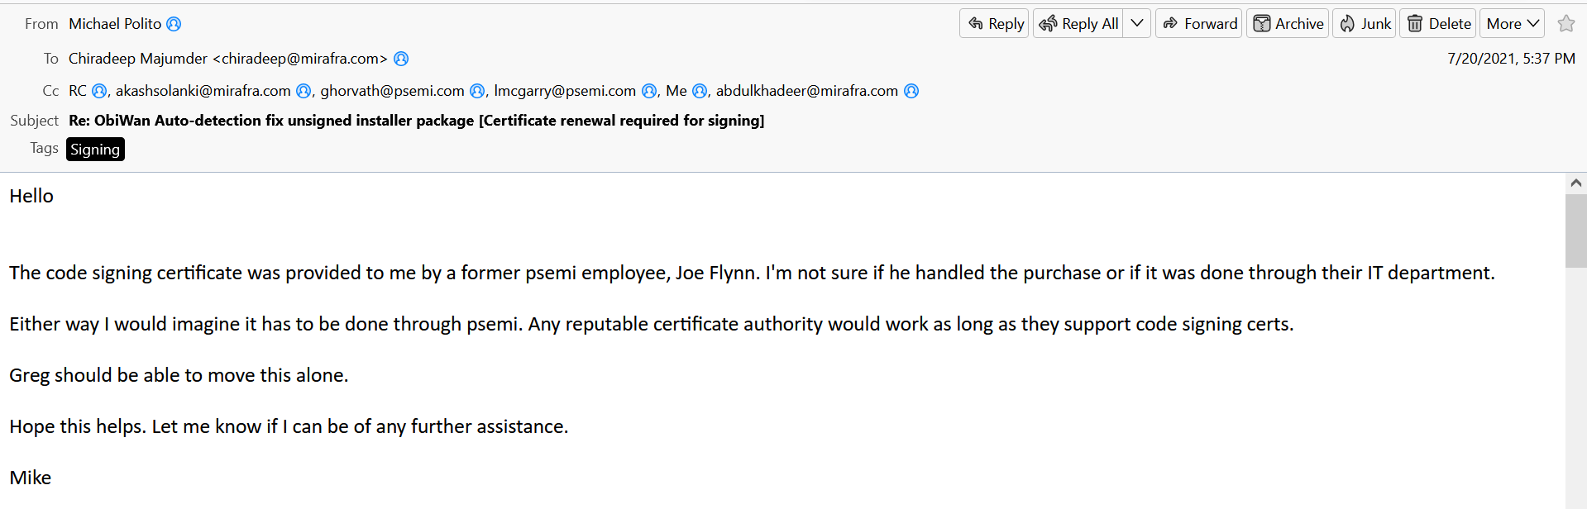

And he further explains and educates Greg about the same :

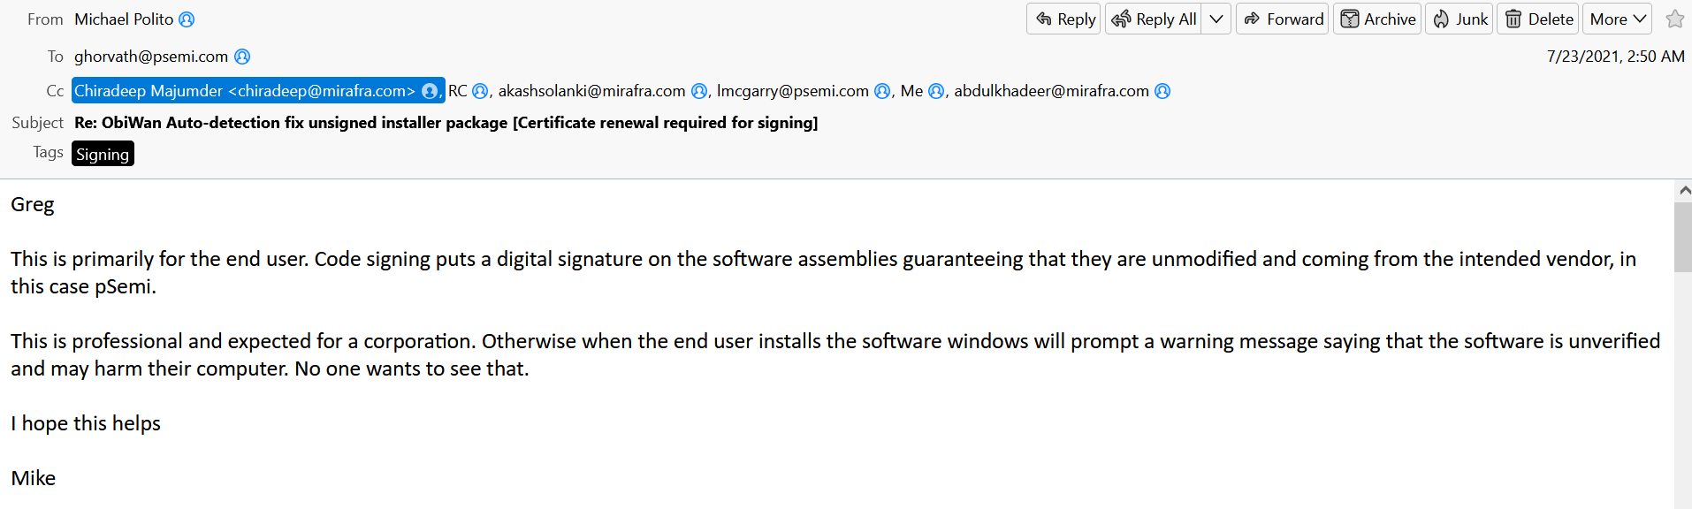
After this there we no initiatives done from Psemi regarding the purchase of the certificates. Hence we were not able to proceed further.
How code signing works in Murata Studio :-
Once the certificates are purchased by Psemi,
Go to “……..muratastudio\Tools\Signing\Cert” and replace the certificates with newer one.
Then edit the .bat files via which we sign this installer.
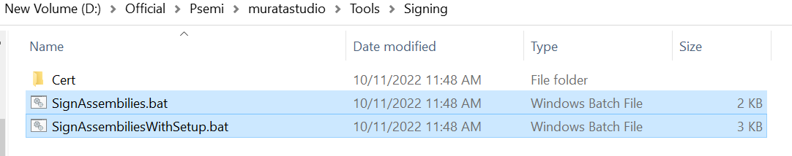
The above two .bat files are responsible for signing the installer and dll.s
For signing we need to first install Signtool.exe downloaded from internet.
Then this signtool path has to be set in GAC.
Once it is done edit the .bat file with the new certificate name and corresponing PW.
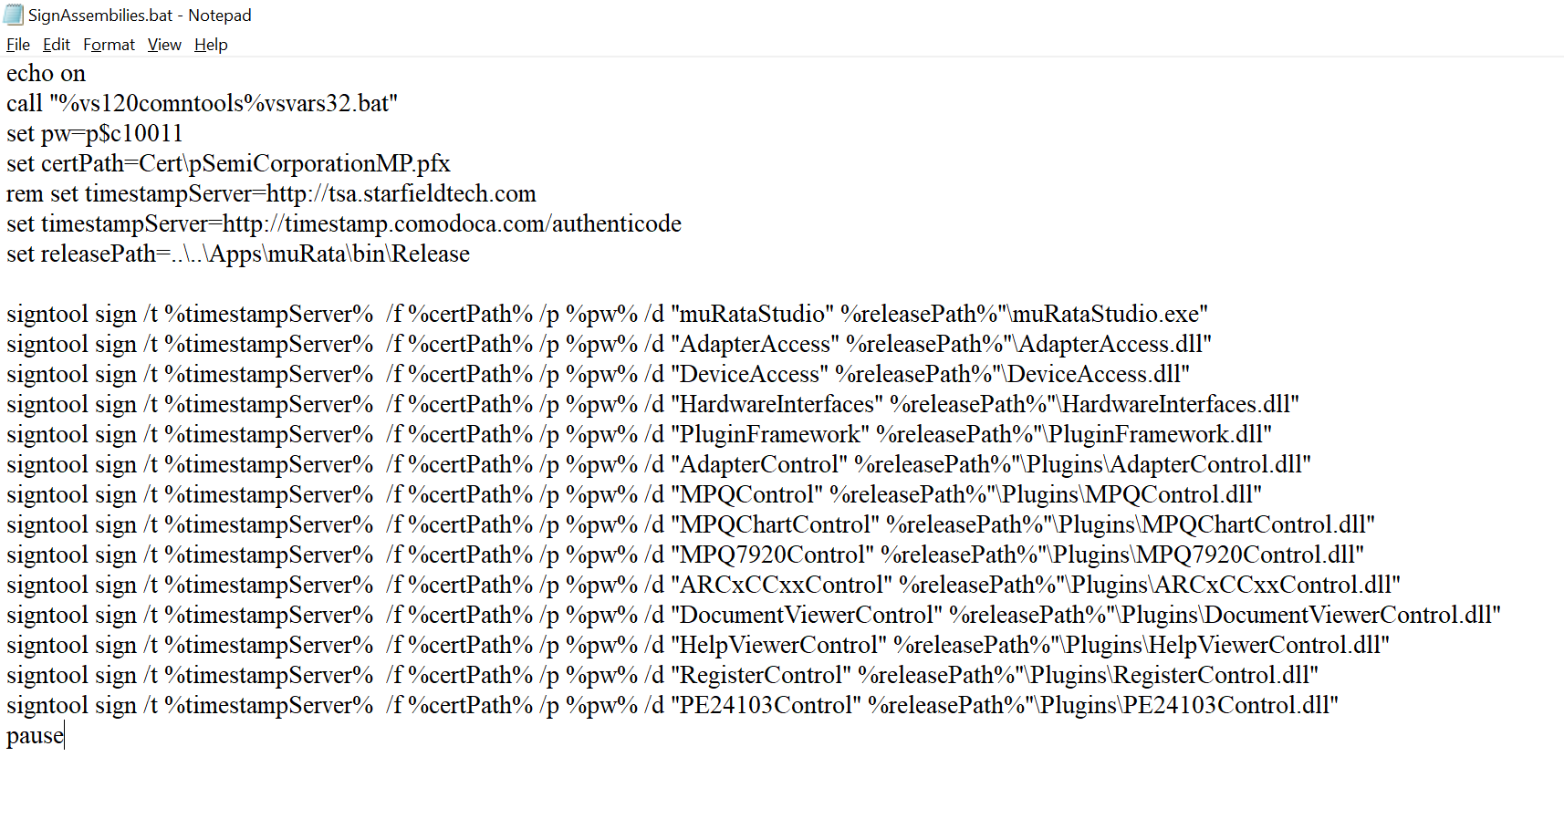
The above code in .bat shows that the signtool is used to sign all the assemblies mentioned in the list including dll’s and exe with the PW.
Replace the Certpath , PW in the file with the updated ones.
Once this is done , edit the SignAssembiliesWithSetup.bat as well.
After that we have to add this .bat file execution on VS project. For that right click murata project and select Properties.
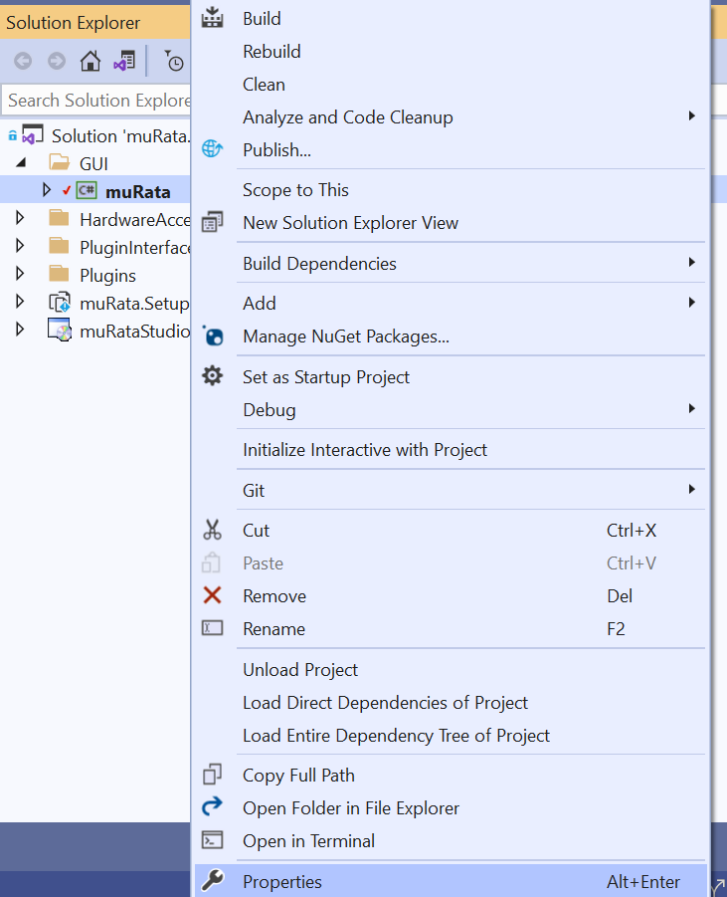

Once the Window is opened , Select Build Events and add those .bat files in Post Build events section
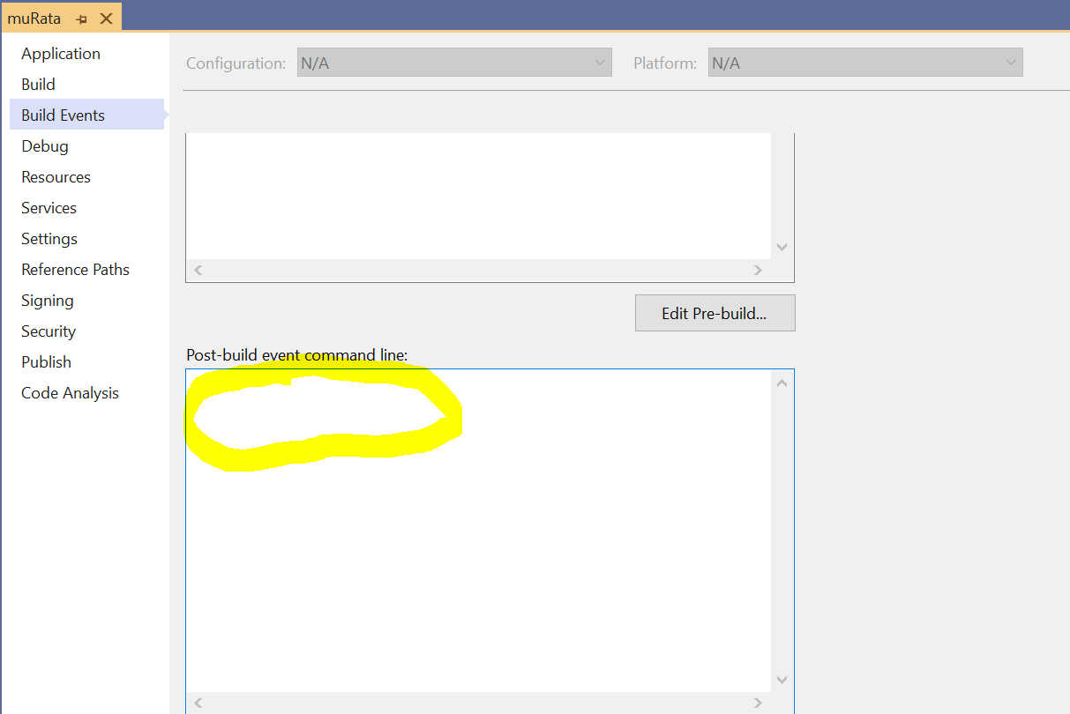

Once this is done, build in Release mode and check the output section to see whether the signing is successful or not. If it is success, then signing done message will be present. Else error will be shown on output window.
Also verify whether harming message comes while installing the .msi in any other PC other than the developed computer.

